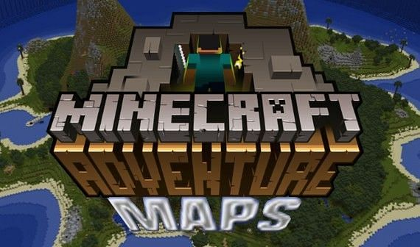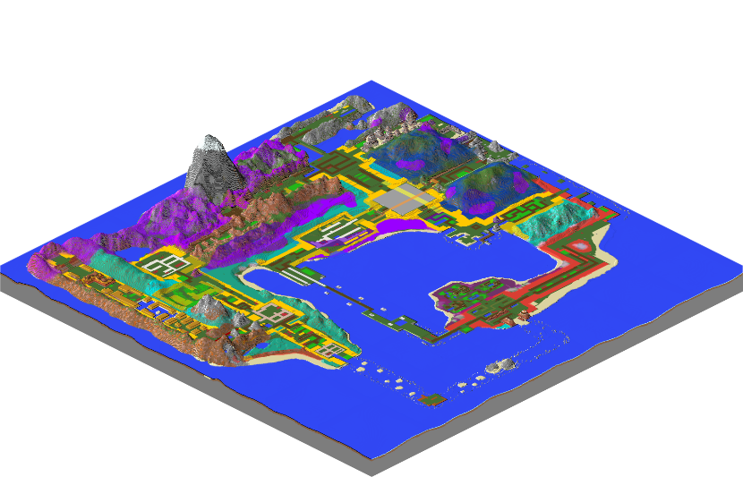

For this dojo session, it was all about +CHILDNAME+ transitioning into the next stage of our project work!

Similarly to the beginning of the Camp, +CHILDNAME+ researched and imported a custom Adventure Map to scout and explore - not too dissimilar to location scouting on a real live-action masterpiece!

For those of you not in the loop (who can blame you!?) Minecraft adventure maps are self-contained experiences that are less about building and more about exploring, battling, uncovering plots and secrets. Navigating exotics locations, dealing with traps and solving puzzles are all to be expected on these journeys! While many of them can be quite happily played solo, a team of up to 4 others can be made in multiplayer.

I’m sure +CHILDNAME+ can present a list of their favourite YouTubers and if they are Minecraft Creators, it is likely they have many projects which are dedicated to playthroughs of Adventure Maps.

So, in the style of their favourite creator, injected with some of their own personality. +CHILDNAME+ has begun work on their own version of a ‘Let’s Play’ using all of the storytelling and filmmaking skills learnt and developed up until now!

I’m excited to see the final product!

